


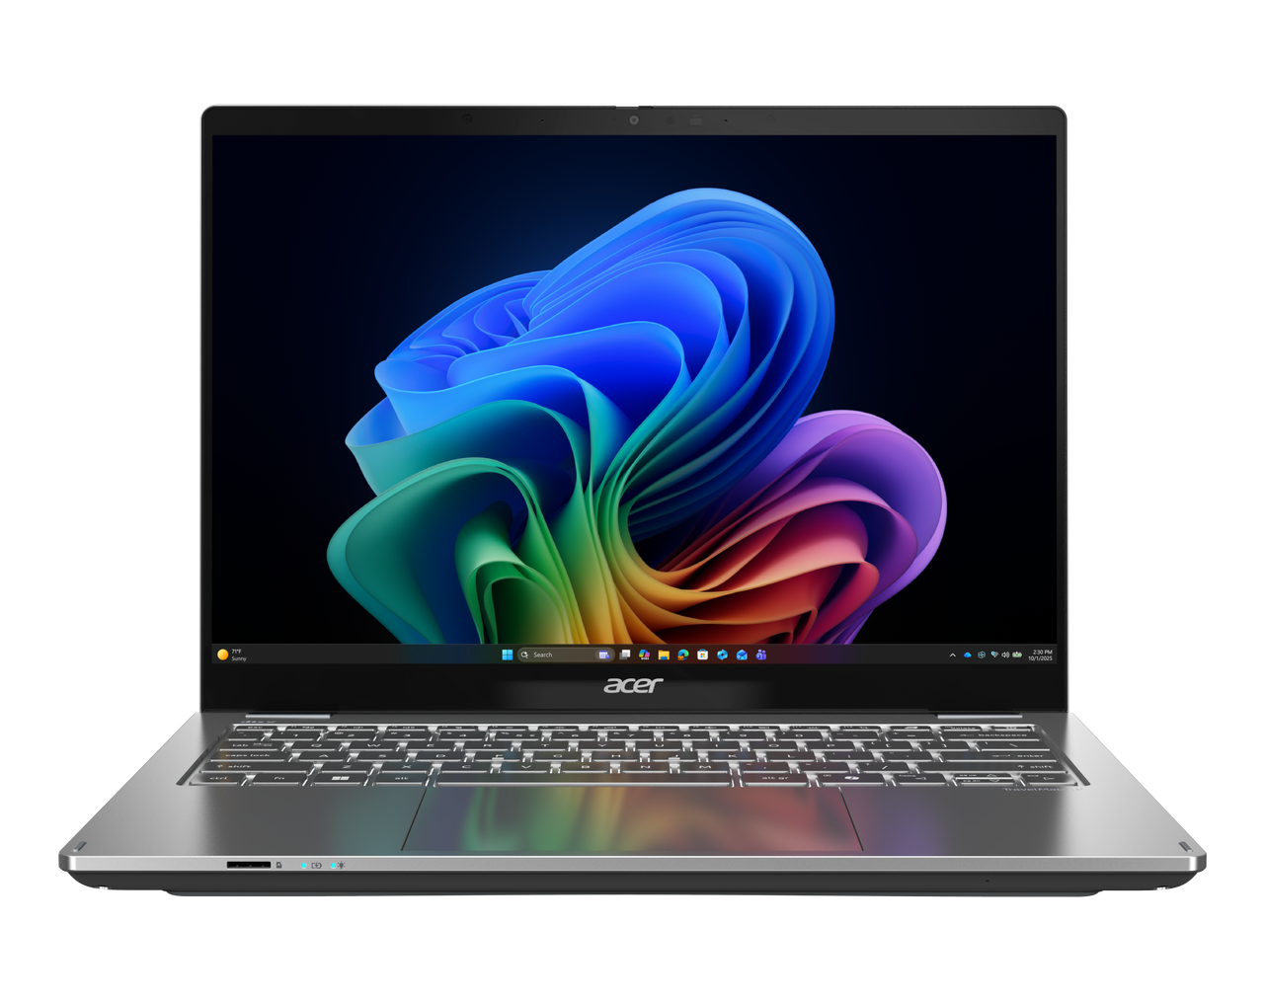

TravelMate P4 Spin 14 AI

SPECIFICATIONS Acer TravelMate P4 Spin 14 AI P414RN-56 | P414RN-76
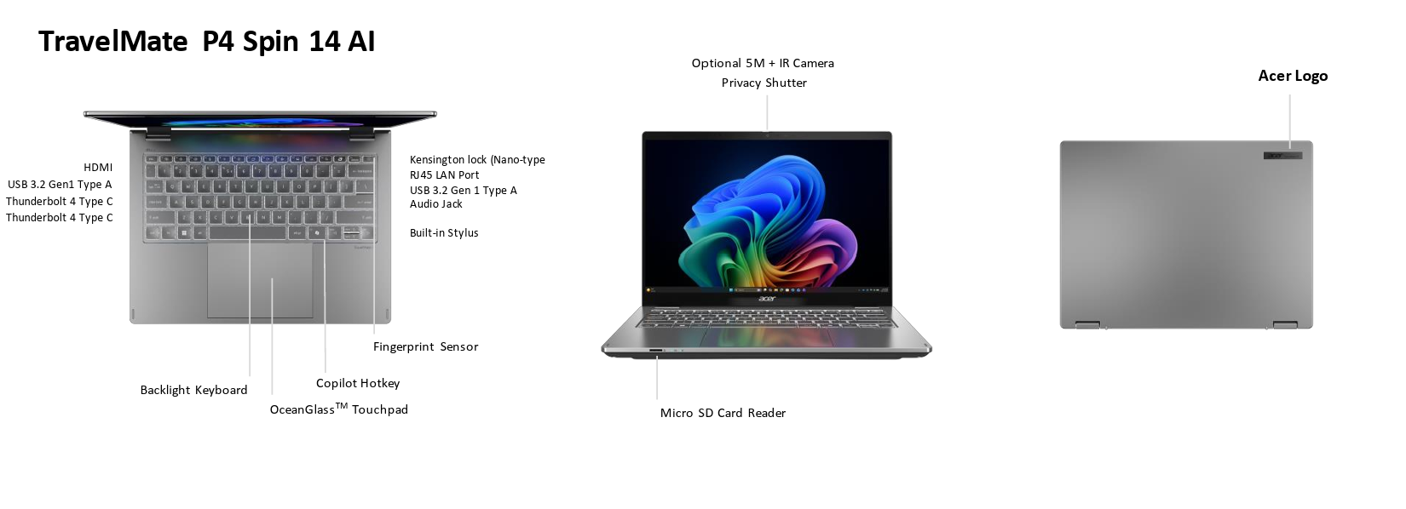
Operating System |  | Windows 11 Pro (Acer recommends Windows 11 Pro for business.)  Windows 11 Home
CPU and Chipset |  | P414RN-56  Intel® Core™ Ultra 7 processor 356H |  |  |  | P414RN-76  Intel® Core™ Ultra 5 processor 322 | Intel® Core™ Ultra 5 processor 325| Intel® Core™ Ultra 5 processor 335| Intel® Core™ Ultra 7 processor 355 | Intel® Core™ Ultra 7 processor 365
Memory |  | Dual-channel DDR5 SDRAM support | Memory Frequency: Up to 5600 MT/s |  | Up to 64 GB of DDR5 system memory using two soDIMM modules
Display |  | 14.0" IPS display, WQXGA+ 2880 x 1800 | 16:10 aspect ratio, color gamut sRGB 100% with integrated multi-touch | Wide viewing angle | Mercury free, environment friendly  - 16:10 aspect ratio  - AES2.0 stylus supportive  - Wide viewing angle up to 170 degrees  - Mercury free, environment friendly |  |  |  | 14.0" WUXGA 1920 x 1200 resolution LED-backlit IPS LCD with integrated multi-touch | 16:10 aspect ratio | Super-slim design | Mercury free, environment friendly  - 16:10 aspect ratio  - AES2.0 stylus supportive  - Wide viewing angle up to 170 degrees  - Mercury free, environment friendly
Graphics |  | Intel® Graphics eligible  Graphics Special Technology:  AVC, HEVC, VP9, AV1, VVC HW Accelerated Video Decode  AVC, HEVC, AV1 HW Accelerated Video Encode | Microsoft DirectX 12 | OpenGL 4.6 | OpenCL 3.0
Audio |  | DTS® X:Ultra Audio, featuring optimized Bass, Loudness, Speaker Protection with up to 3 custom content modes via smart amplifier  Smart Auto switch to Voice enhanced Mode via VOIP  Acer Purified.Voice technology with AI noise reduction in 3 mics array built-in microphones to support Advanced Privacy Mode. Features include far-field pickup, dynamic noise reduction through neural network, adaptive beam forming, and pre-defined personal and conference call modes. |  |  |  |  | Compatible with Cortana with Voice | Acer TrueHarmony Technology for lower distortion, wider frequency range, headphone-like audio and powerful sound  High SNR DAC with 2.1 Vrms out capability and can driver high impedance headphone (up to 600 ohm)
Storage |  | Solid state drive | SSD slot: 1256 GB / 512 GB / 1 TB, PCIe Gen4, 16 Gb/s, NVMe
Webcam |  | Video conferencing  UFC with Double T-Type USB 5M Camera | Compatible with Windows only | 2880 x 1800 Resolution | 1800p 5M Video at 30 FPS with Temporal Noise Reduction | Dual Mic (33 mm + 33 mm) | Blue glass lens  UFC with USB 5M +IR Camera | Compatible with Windows only | 2880 x 1800 Resolution | 1800p 5M Video at 30 FPS with Temporal Noise Reduction | Dual Mic | Blue glass lens
Wireless and Networking |  | WLAN:  •Wi-Fi 7 Wireless LAN  •802.11 a/b/g/n/ac/ax/be  •Band: 2.4 GHz, 5 GHz, and 6 GHz  •2x2 MIMO technology  •Intel® Connectivity Performance Suite (ICPS) | LAN:  • Gigabit Ethernet, Wake-on-LAN ready  WPAN:  •Supports Bluetooth® 5.4 or above for Wi-Fi 7 wireless card.  •Supports Bluetooth LE Audio (LC3).
Security |  | Power keycap fingerprint reader with on-chip matching design | Acer ProShield Plus security manager includes: Data Protection: File & Folder Encryption and Decryption, Personal Security Drive | Data Removal: File Shredding | Security Alert: Invalid Access Alert, Security Report  Discrete Trusted Platform Module (TPM) solution | BIOS user, supervisor, HDD(OPAL) password | Kensington lock (Nano-type) | Camera shutter
Dimensions and Weight |  | Dimensions  312.8 (W) x 231.6 (D) x 16.9/17.1 (H) mm (12.31 x 9.12 x 0.67/0.67 inches) with Metal A Cover |  |  | Weight  1.365 kg (3.01 lbs.) with 4-cell battery pack, WQXGA display
Power Adapter and Battery |  | Power Adapter  •100 W PD AC adapter  •5 V / 3 A or 9 V / 3 A or 12 V / 3 A or 15 V / 3 A or 20 V / 5 A as output power  •Black color with Acer logo  •Brick type AC pins  •Paper sleeve packaging |  | •65 W PD AC adapter  •5 V / 3 A or 9 V / 3 A or 12 V / 3 A or 15 V / 3 A or 20 V / 3.25 A as output power  •Black color with Acer logo  •Brick type AC pins  •Paper sleeve packaging |  | Battery  •56 Wh 4-cell Li-ion battery  •Supports Fast Charging technology  •For models with WUXGA Panel + SSD  Battery life: |  | •Supports Fast Charging technology  •For models with WUXGA Panel + SSD  Battery life:
Input and Control |  | Keyboard  80-/81-/84-key Acer backlight keyboard layout with international language support including indicators of CapsLock and F4/Microphone mute. Anti-bacteria treatment  Caps Lock indicator  F4 microphone mute indicator  Spill Resistant Keyboard based on MIL-STD-810H Method506.6 Procedure III Drip test |  |  |  | Touchpad  Multi-gesture touchpad, supporting two-finger scroll; pinch; gestures to open Cortana, Action Center, multitasking; application commands | Microsoft Precision Touchpad certification | Moisture resistant | Corning® Gorilla® Glass |  | Control keys  Copilot Key  TravelMate Sense key
Windows Desktop Apps |  | In-House Applications  Acer AI Image Generator | Acer LiveArt | Acer ORD Service | Acer QuickPanel | TravelMate Sense
System Compliance |  | ENERGY STAR® | Wi-Fi® | EPEAT® registered
Warranty |  | One-year International Travelers Warranty (ITW)
Disclaimers
• | Specifications vary depending on model.
• | Shared system memory may be allocated to support graphics, depending on system memory size and other factors. Actual system memory available to the operating system will be reduced by any memory used by the graphics solution and resources required by the operating environment.
• | Memory speed may vary, depending on the CPU, chipset or memory fitted.
• | All brands and product names mentioned herein include trademarks of their respective companies and are used solely to describe or identify the products.
• | Not all features indicated are supported on all SKUs
• | 1 GB is 1 billion bytes. Actual formatted capacity is less and may vary depending on preloaded materials and operating environment. Acer Recovery Management uses a portion of the stated hard disk capacity as dedicated backup space.
• | Minor variations in system dimensions are possible due to the manufacturing process.
• | Weight may vary depending on product configuration, vendor components, manufacturing variability, and selected options.
• | Bundled software may vary depending on hardware configuration, OS and regional availability.
• | EPEAT® registration varies by country. See http://www.epeat.net/ for registration status for each country.

Product Sheet is based on TravelMate P414RN-56 Specifications (v1-0-0) (Preview) and TravelMate P414RN-76 Specifications (v1-0-0) (Preview)

